**DAY -10 Practice**

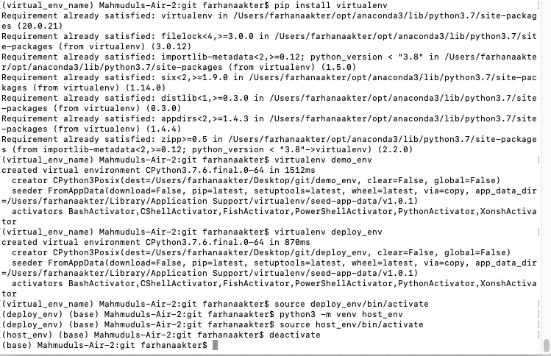

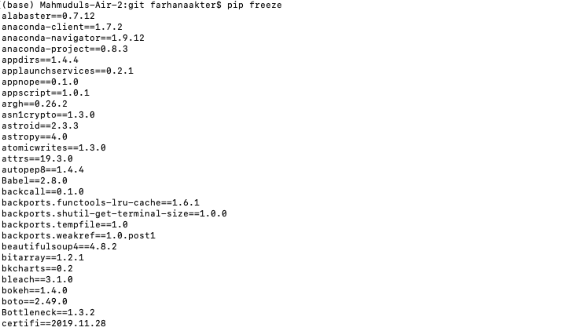

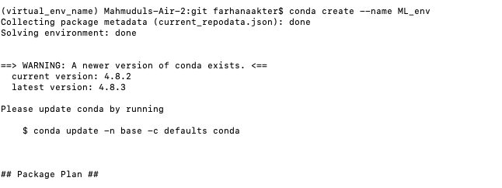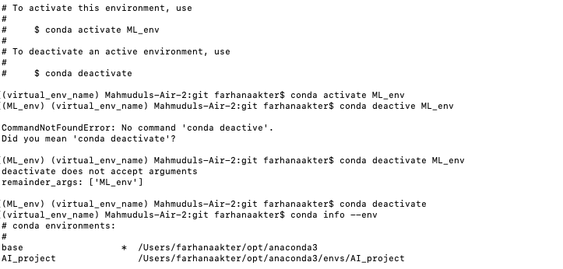

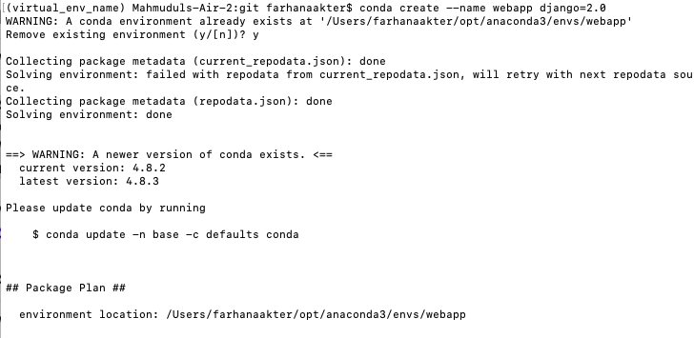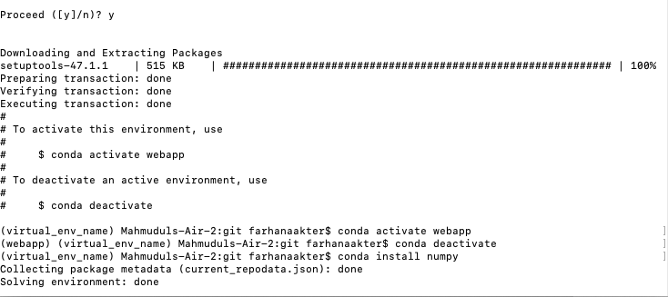

Task 2

**Static and Dynamic Web Page:**

The static web pages display the same content each time when someone visits it, whereas in dynamic web pages the page content changes according to the user.

Static websites use only client-side HTML and CSS code while dynamic websites rely on both client-side and server-side scripting languages such as JavaScript, PHP, or ASP. When a user accesses a dynamic website, the site can be changed through code that is run in the browser and/or on the server.

